

Configuring URL Filtering for An
Elementary School Environment

Rui Zhao, CCNA
Purpose:

The purpose of this lab is the implementation of URL filtering Palo Alto PA-220 firewall for an Elementary School environment by filtering specific type of genres of traffic such as dating, gaming, high-risk domains, and more. This implementation of filtering allows us to not only prevent unwanted domains across our network but also possessing the ability to sightsee the activities on the network, cultivating a secure, efficient, and controllable environment.

Background Information:

URL filtering is a service, mostly provided by firewalls, that protects networks and consumers against malicious or unwanted domains. This service enables real time analysis and categorization of domains, utilizing machine learning powered web protection engines that block malicious websites. The URL filtering service employs policy rules that are modified in the administrative interface, where administrators could specify which domains should be accessible and which should be blocked. When a consumer under the Palo Alto PA-220 firewall URL filtering service requests a site, the firewall would check the local cache for its URL category assigned by administrators.

The Local Inline Categorization, known as inline machine learning, is the tool used to alert users of hazard websites by dynamically analyzing contents through a series of machine learning models. Furthermore, the categorization is flexible, and you can create rules and exceptions for certain websites in case of false positives. The machine learning models are consistently updated, keeping up with the latest dates of potential malicious detections.

There are five different actions to filter URLs in URL Filtering profile, which can be accessible in the Web UI interface. This includes allow (permits URL traffic and traffic isn’t logged), block (blocks URL traffic), alert (permits URL traffic but traffic is logged), continue (warns user, but allows user to access site), and override (allows URL traffic when user inputs the correct password). The password to the override command can be configured in the firewall Web UI interface, allowing users with the password to access the site when given permission.

Advanced URL Filtering has been trained and continuously updated as time goes on, improving malicious URL detection and mitigating phishing. This filtering process analyzes complex malicious patterns and behaviors over extensive materials and trains on new patterns. The URL request process goes through the firewall protocol, where the traffic has to go through both the firewall’s URL Filtering Incline ML feature along with the URL Filtering | Policy Enforcement step, with the web payload data sent to the Advanced URL Filtering cloud server to perform real time analysis of the data in hand. The firewall then determines the URL category in groups in order of precedence: custom URL categories, external dynamic lists (EDLs), predefined URL categories.
URL Filtering profiles control how traffic is handled to specific URL categories. Administrators can configure the URL Filtering profile’s security protocols that allow access to the internet. This includes features such as site access, permission for user-credential submissions, safe search, etc. The default profile that is preconfigured by filtering blocks threat-prone categories like malware and phishing. Administrators can use the profile as format for setting up their own individual security protocols to control the flow of traffic and monitoring.

Lab Summary:

Using the Palo Alto PA-220 firewall, we constructed a URL Filtering profile for an Elementary School environment. Not only did we filter the appropriate traffic for the environment but also configured the override feature in special cases where access to traffic should be permitted.

Lab Commands:

First, head over to Device Certificate Management Certificates Device Certificates. You would need to generate certificates on order to configure SSL/TLS Service Profiles. Click on Add.

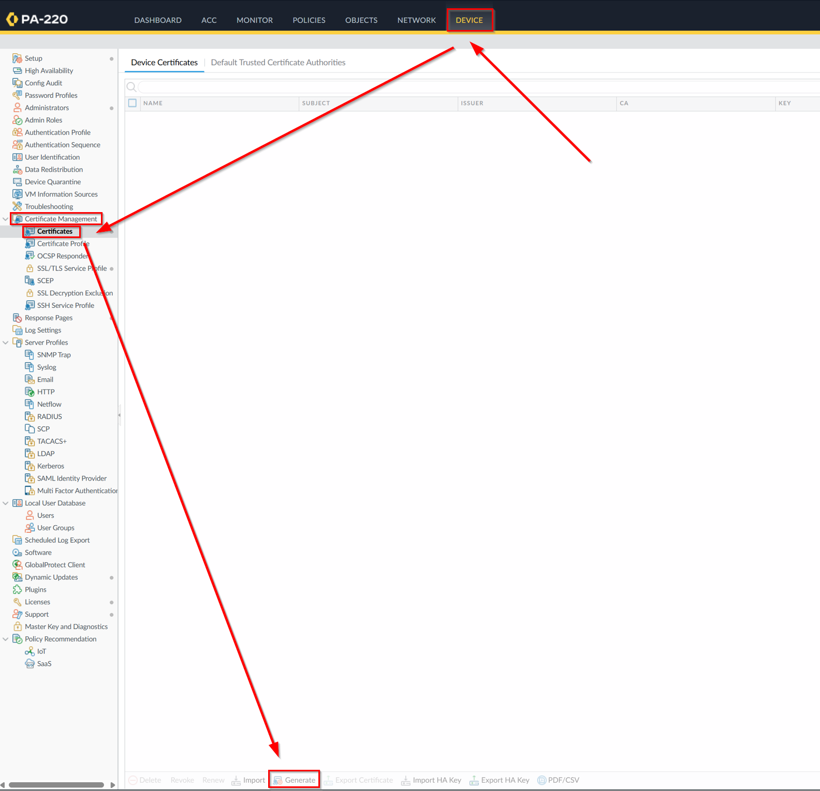

We’ll be making a Root CA (Certificate Authority) certificate. A Certificate Authority certificate issues and manages digital certificates, which we’ll be needing to generate our main certification. Copy the configuration below, with 192.168.1.254 as Common Name and hit generate.

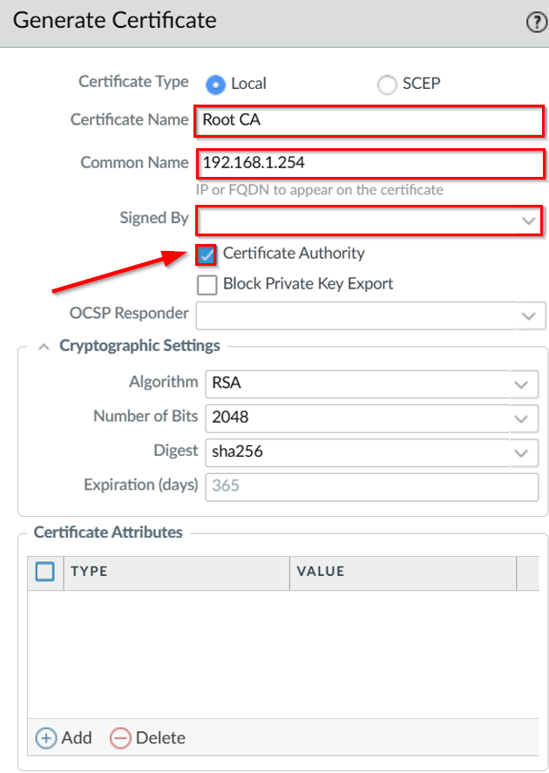

Click on Root CA again, check Trusted Root CA.

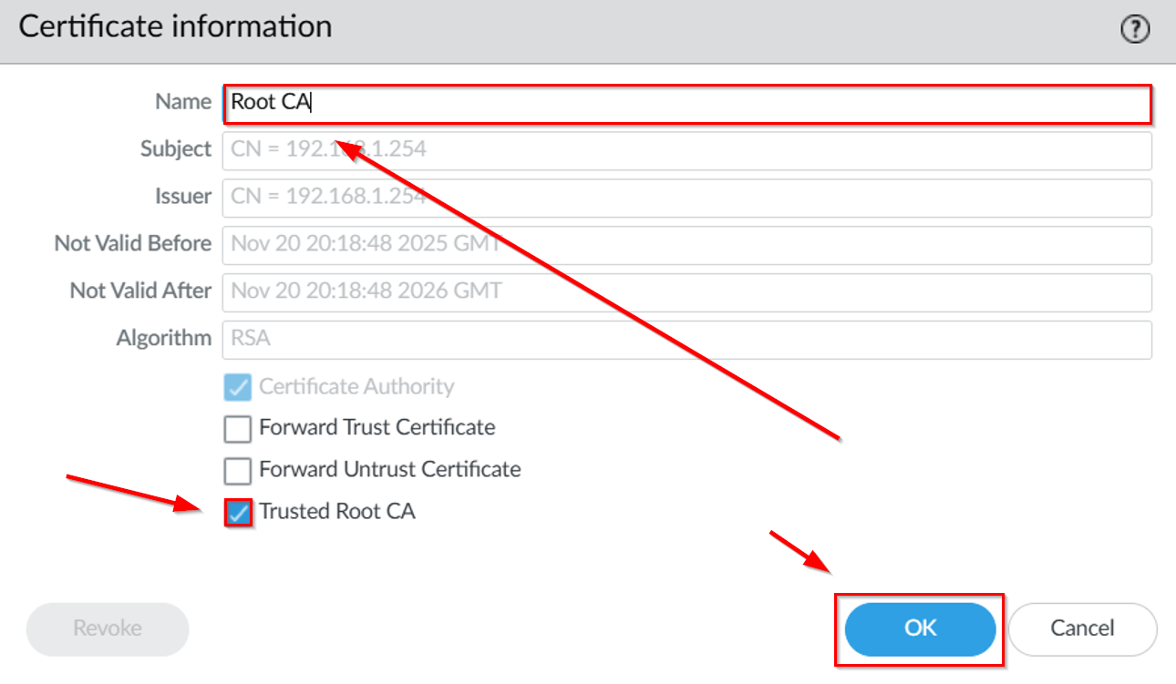
Now we can generate the Elementary Certification. Copy this configuration down below, with 192.168.40.18 as our Common Name (fetched from DNS servers). Sign it by our Root CA and hit generate.

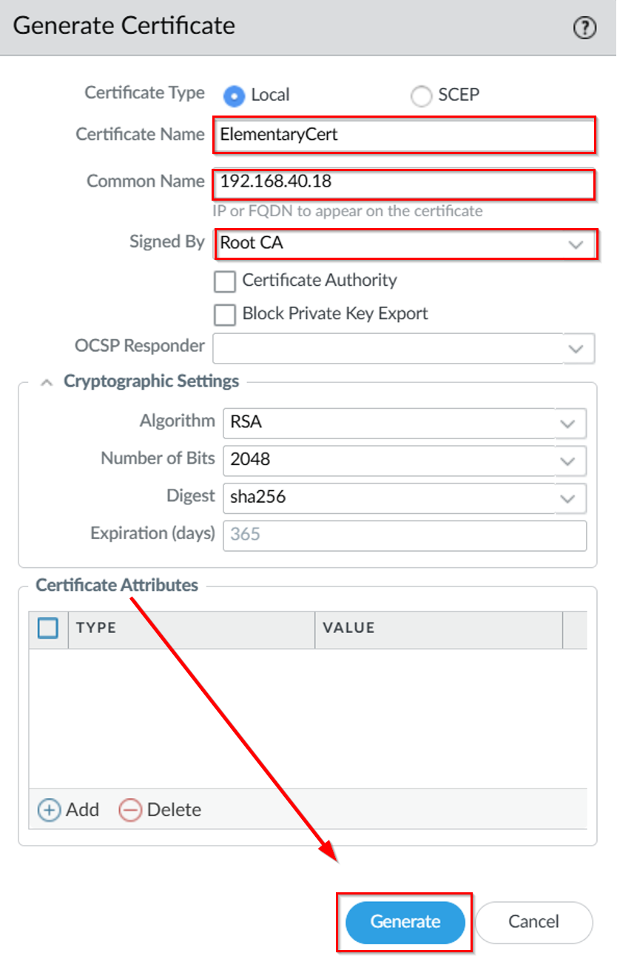

Next step is configurating the SSL/TLS Service Profile. Head over to Device Certificate Management SSL/TLS Service Profile and click add.

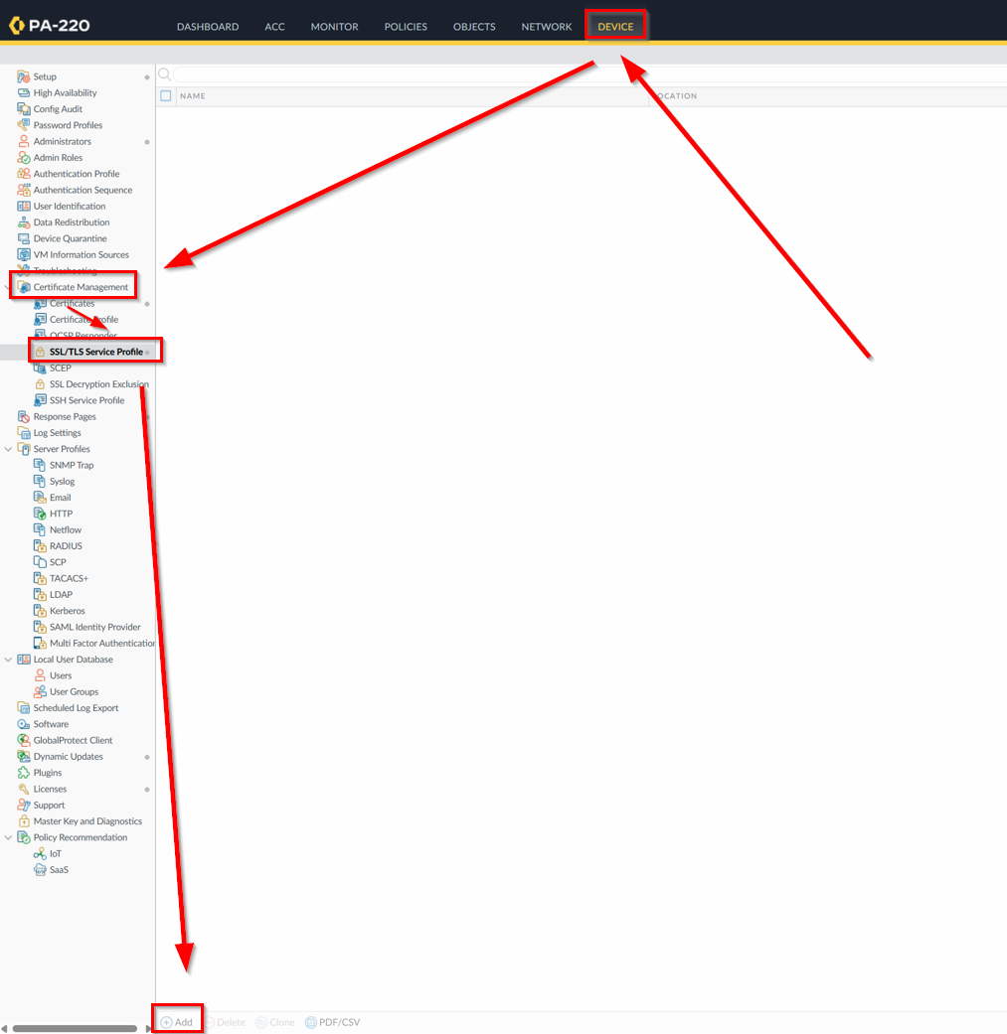

Using our ElementaryCert certification from before, we can reference it in our Certificate section. Set Min Version to TLSv1.2 and Max Version to Max. These are encryption protocols that secure data transmitted over the internet, providing strong security features. After that, click OK.

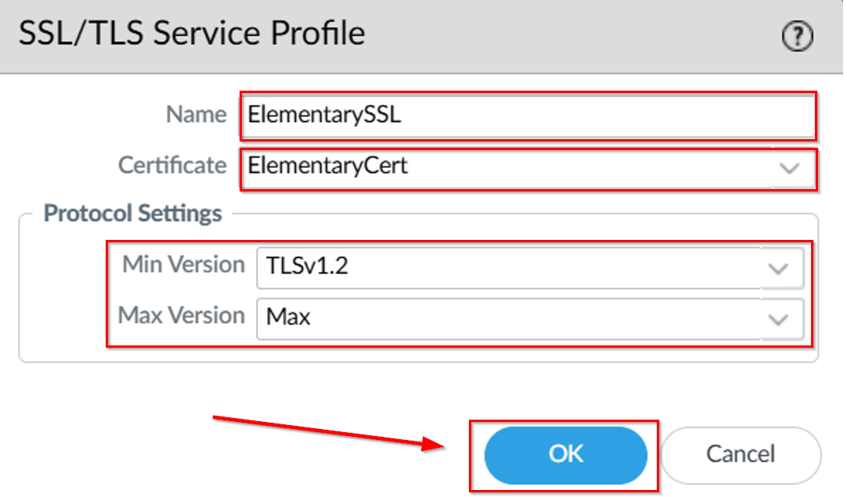

Then, for us to enable overriding on URL traffic in case we want to access a blocked site, head over to Device Setup Content-ID. Then, in the URL Admin Override section, click on Add.

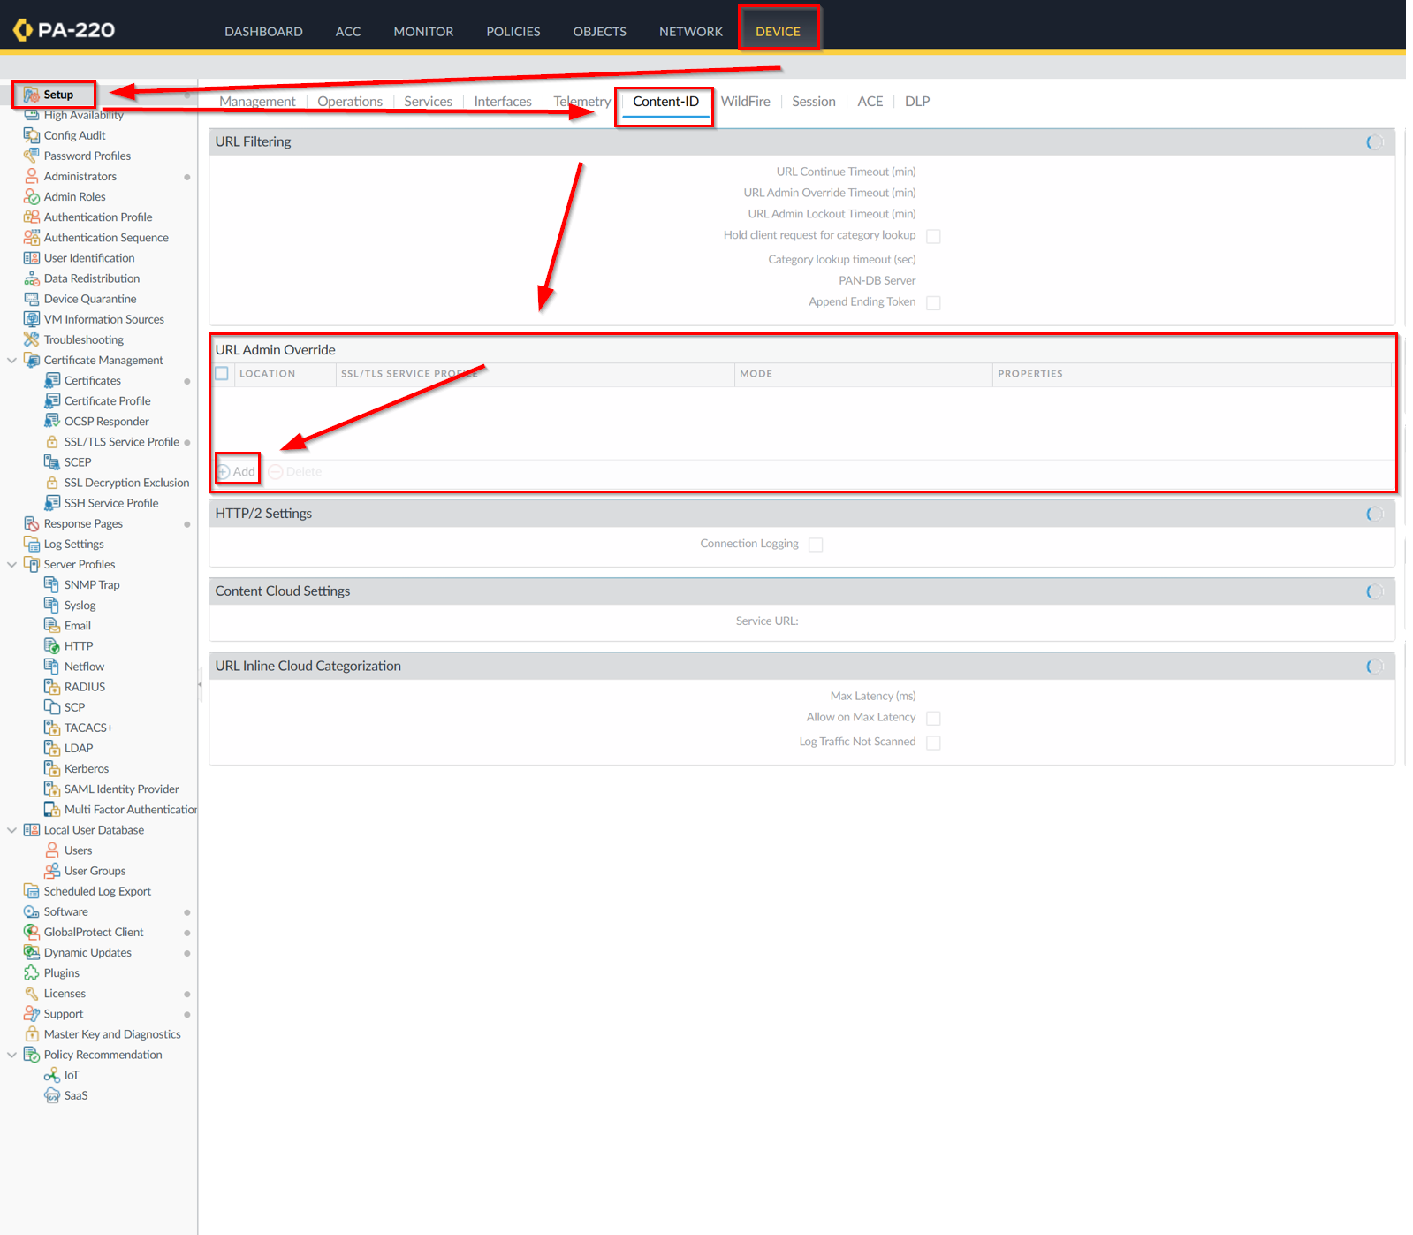

Inside, configure the password you would want to use to access blocked sites that are marked as “override” under traffic configuration (next steps). Set SSL/TLS Service Profile to ElementarySSL. Make sure it is set to Transparent mode.

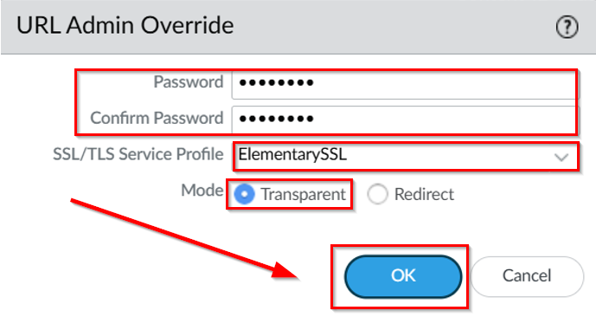
To get the URL Filtering working, go to Objects Security Profiles URL Filtering and press Add.

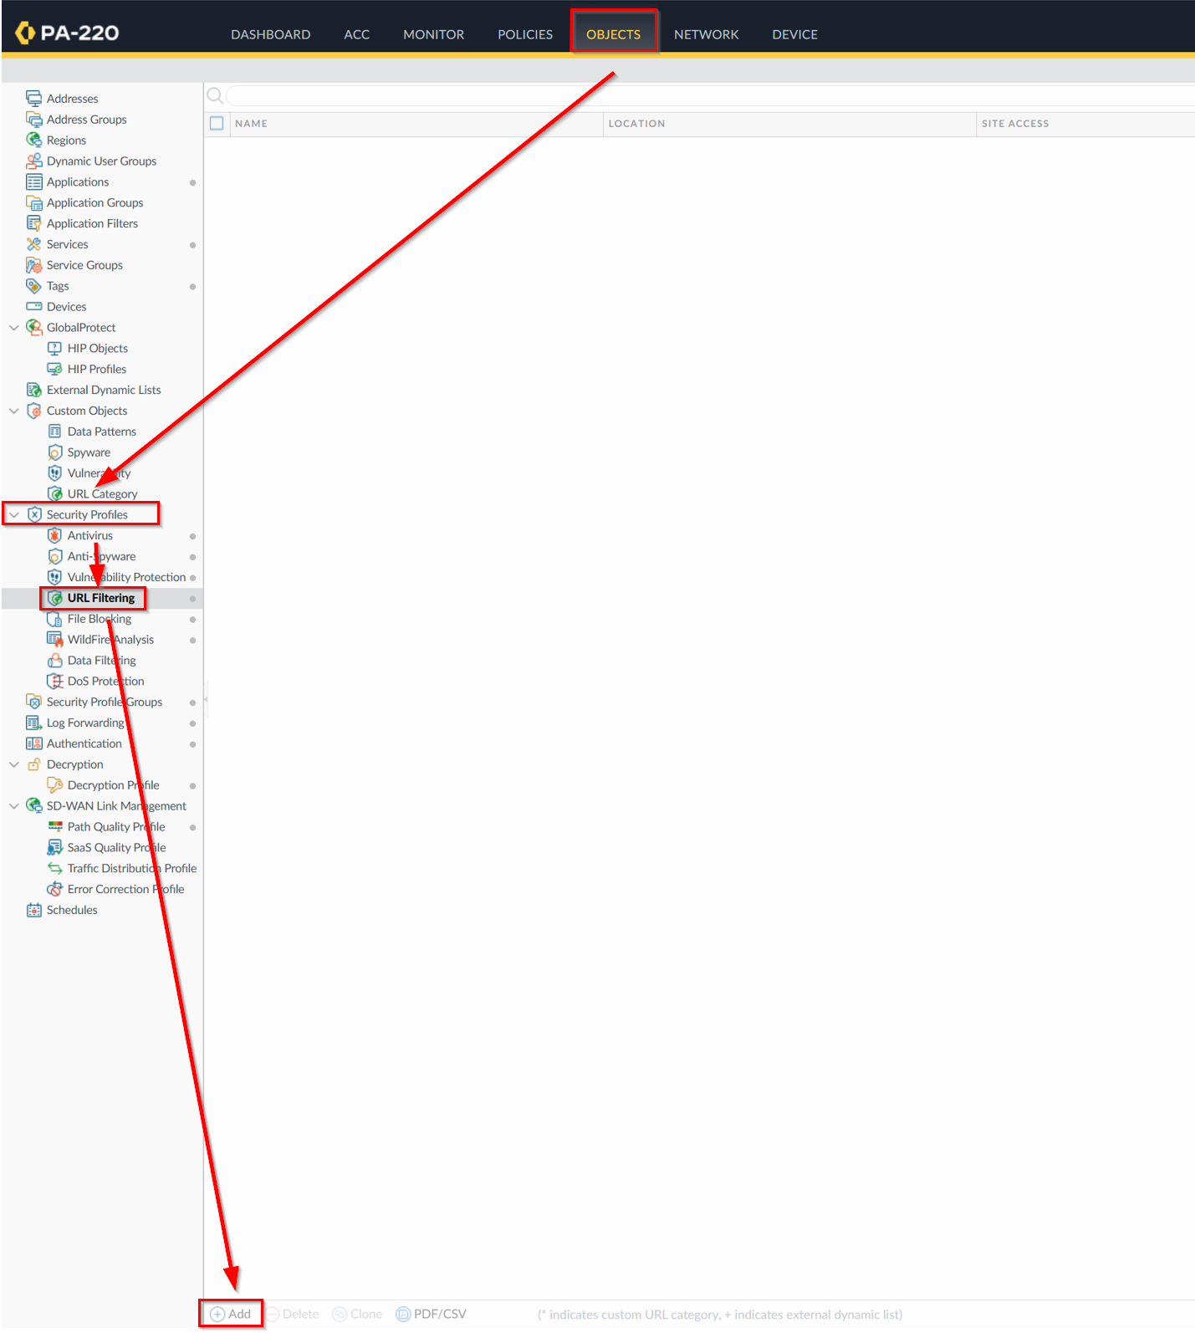

In this configuration interface, you will be able to set the permissions for site access and user credential submissions. The options for site access are as follows: allow, block, override, alert, and continue. Configure these appropriately to the Elementary URL Filtering environment then check the boxes and press OK.

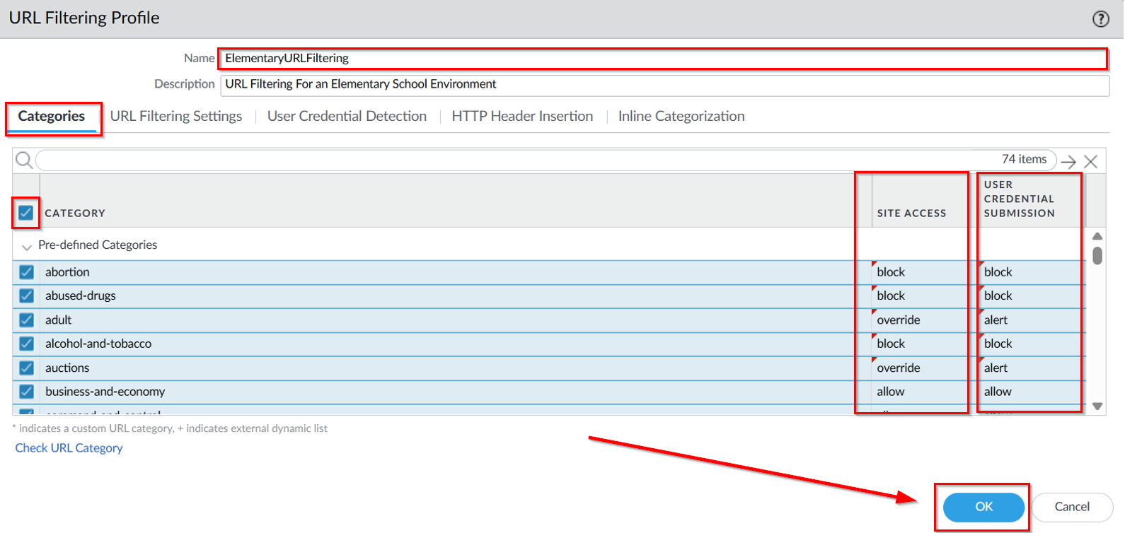
In order to set URL Filtering as active, go to Policies Security. Click on your internet outgoing interface.

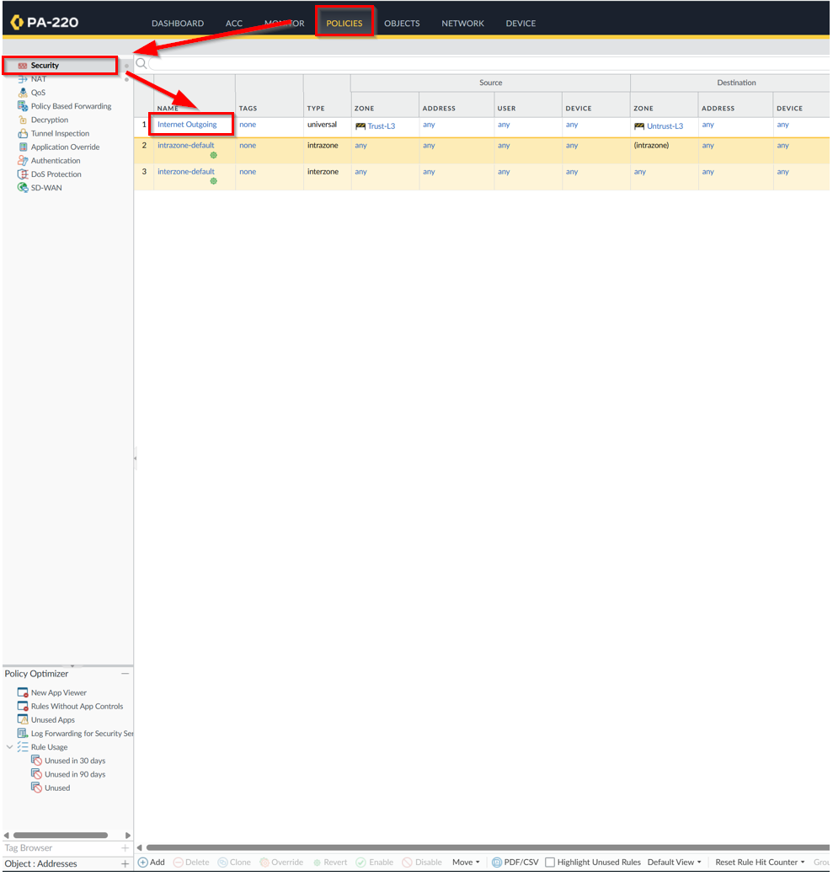

Then, go to Actions and under Profile settings URL Filtering, put on your Elementary URL Filtering profile and press OK.

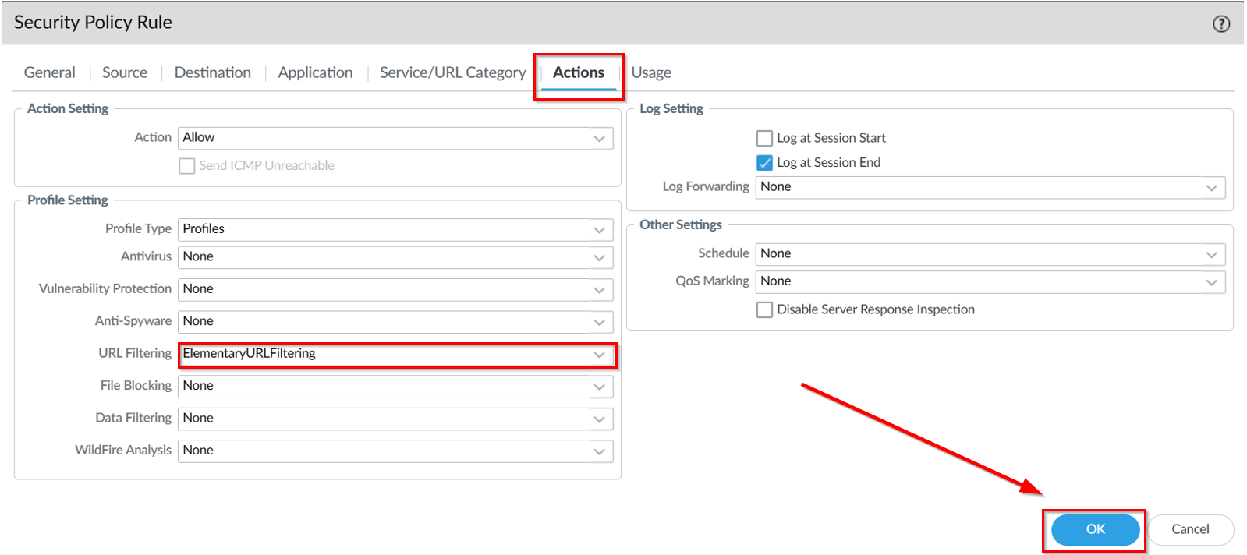

Congratulations, you have successfully configured URL Filtering for a Elementary school environment.
Problems:

The first issue arose when we self-signed our certificate incorrectly. Self-assigning my elementary certificate without a root certification authority sign results in invalid certification, which invalidates our override function. Of course, this issue was eventually fixed by constructing our Root CA in order to sign our elementary certification along with updating it on SSL/TLS Service profile. We’ve also configured its Common Name of Elementary Certification to its DNS ip address 192.168.40.18 as opposed to 192.168.1.254 that generated issues with duplicate certificates when committing changes.

The second issue arose when we couldn’t reach any domains even if the URL Filtering setting was turned off. When overriding the auction category, websites such as eBay should be blocked. While under the Monitoring tab we can see that eBay was indeed marked as auction and was in theory successfully in the overriding screen, eBay showed a different screen that said cannot reach this server instead. Furthermore, not even the search engine worked, showing the same error screen. This problem persisted even when I set everything to allow under the Elementary URL Filtering profile. Thinking it was a hardware issue, we factory reset our entire firewall and reconfigured SOHO and URL filtering, and this problem persisted. We soon realized that this wasn’t working only on the Chrome browser, but it works in Microsoft edge. The firewall URL Filtering was working, just under different domains, likely due to one of Chrome’s features or extension settings.

Conclusion:

In conclusion, this lab has introduced us hands-on experience regarding the fundamentals of configuring a URL filtering environment for a professional environment. Furthermore, researching this lab allowed me to acknowledge abstract details like Local Incline Categorization, which is machine learning ran categorization, and the different settings for managing site access and user credential submissions, such as allow, block, alert, continue, and especially override.

Teacher Signoff Page of Lab Completed:

